POWER BI MINI PROJECT REPORT
Employment Overview and AI Risk Analysis
Introduction
This project was developed using Microsoft Power BI to analyze employment-related data and present meaningful insights through an interactive dashboard.
The project focuses on understanding the distribution of employees across different industries, education levels, employment statuses, locations and recorded dates. In addition, the project analyzes potential AI-related employment risk among different employee groups.
Power BI was used to transform the employment dataset into an interactive visual dashboard containing charts, cards, slicers, maps and tables. The dashboard helps users understand workforce patterns and identify employee groups and industries that may require attention due to AI and automation-related risks.

Messy_Employment_India_Dataset
The dataset contains employment-related information that was used to analyze workforce characteristics and AI-related employment risk.
Important fields used in the project
- Employees
- Industry
- Education
- Employment Status
- Location
- Date Recorded
- Age Group
- AI Risk Count
- AI Risk %
- AI Risk LEVEL
- Average
The dataset was analyzed using Power BI and the relevant fields were used in different visuals and dashboard components.

Data Preparation and Transformation
The employment dataset was loaded into Power BI and prepared for analysis.
The connection have done in model view:
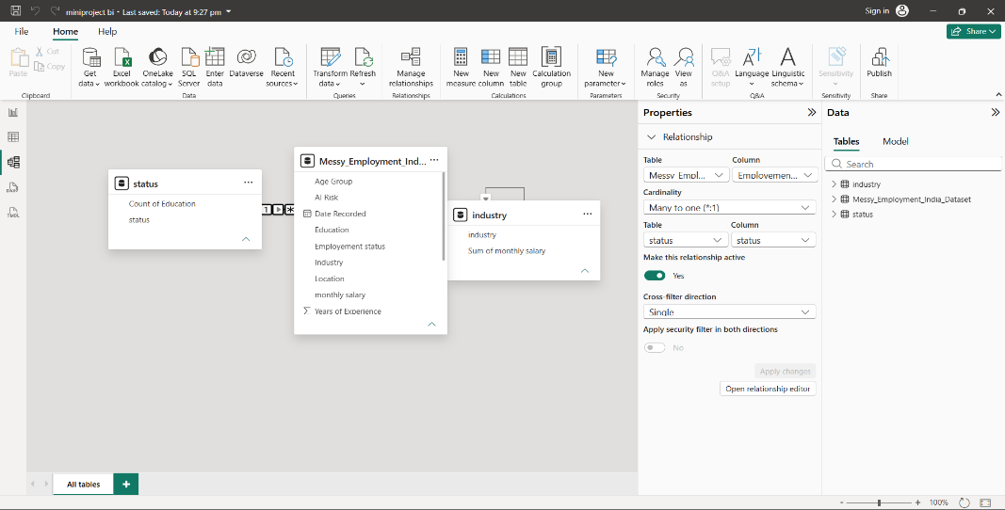
Power BI Dashboard Development
The final Power BI report consists of main pages:
- Employee Overview
- AI Risk and Employment Analysis

Dashboard – Employee Overview
EMPLOYMENT OVERVIEW
This page provides an overall view of the employment dataset.
The page contains different visualizations to analyze employee distribution.
Map
A map visual was used to display the geographical distribution of employees.
The following fields were used in the map analysis:
- Location
- Industry
- Employment Status
- Date Recorded
The map helps identify where employees are located and how workforce distribution varies geographically.
Donut Chart
A donut chart was created to analyze the distribution of employees based on employment-related categories.
The visual uses fields such as:
- Employment Status
- Industry
- Date Recorded
This visual makes it easier to understand the proportion of employees belonging to different employment categories.

Clustered Column Chart
A clustered column chart was created to compare employee numbers across:
- Industry
- Education
- Date Recorded
This helps identify industries and education groups with larger employee populations.
Bar Chart
A bar chart was used to compare the number of employees across industries and recorded dates.
This provides a clear comparison of workforce size between different industries.

Date Slicer
A date slicer was added to allow users to filter the dashboard based on Date Recorded.
Users can select a particular date or time period and analyze the corresponding employment information.

Industry Slicer
An industry slicer was added to allow users to select a particular industry.
This makes the dashboard interactive because selecting an industry automatically changes the related visuals.

Card Visuals
Card visuals were used to display important summary information.
The cards provide quick access to important numerical information such as employee counts and average-related information.

Matrix
matrix visual was included to provide a detailed view of
- Employment Status
This allows the user to examine the underlying employment information in a structured format.

6.9 Line Chart
A line chart was used to analyze employee trends over time.
The chart helps identify increases and decreases in employment levels across different recorded dates.

Dashboard – AI Risk and Employment Analysis
AI RISK AND EMPLOYMENT ANALYSIS
This page focuses specifically on AI-related employment risk.
It provides a deeper analysis of employees who may be affected by AI, automation and technological changes.

AI Risk KPI Cards
Four important card visuals were created on this page.
These include:
Total Employees
Displays the number of employees within the selected filter context.
AI Risk Count
Displays the number of employees identified as being at AI-related employment risk.
AI Risk %
Displays the percentage of employees associated with AI-related employment risk.
AI Risk LEVEL
Displays the calculated AI risk level for the selected context.
These KPI cards allow users to understand the overall AI-risk situation quickly.

AI Risk by Industry
A bar chart was created to compare AI-risk employee counts across different industries.
The visual uses:
- Industry
- Age Group
- AI Risk Count
This helps identify industries that have a comparatively larger number of employees exposed to AI-related employment risk.

AI Risk by Education
A pie chart was created to analyze AI-risk employees based on education level.
Education categories are compared using the AI Risk Count.
This helps determine whether AI-related employment risk is concentrated among a particular education group or distributed across multiple education levels.

AI Risk by Employment Status
A column chart was used to compare AI-risk employees based on employment status.
This helps determine whether AI-related employment risk affects:
- Employed employees
- Unemployed employees
The analysis demonstrates that AI-related risk should not be viewed only as an unemployment issue, because employees who are currently working may also face changes due to AI and automation.

AI Risk Scatter Chart
A scatter chart was included to analyze the relationship between:
- Employees
- Age Group
- AI Risk Count
This visual helps identify employee groups with relatively high workforce sizes and AI-risk counts.

AI Risk Trend Over Time
A line chart was created to analyze AI-risk employee counts over time.
The chart uses:
- Date Recorded
- AI Risk Count
- Age Group
This allows users to identify changes in AI-related employment risk over different periods.

Age Group Slicer
An age-group slicer was added to allow users to analyze AI risk for specific age groups.
This makes it possible to compare AI risk among different employee age categories.
Location and Age Group Slicer
Another slicer was included using:
- Location
- Age Group
This allows users to filter the AI-risk dashboard according to geographical location and employee age group.

DAX Calculated
The project uses calculated analytical fields to support the dashboard.
The important calculations used in the final report include:
Average
An average calculation was used to display an average value in the Employee Overview section.
AI Risk Count
An AI Risk Count calculation was used to determine the number of employees falling under the identified AI-risk category.
AI Risk Percentage
The AI Risk % calculation was used to determine the proportion of employees associated with AI-related employment risk.
AI Risk Level
AI Risk LEVEL was used to classify or represent the level of AI-related employment risk.
Age Group
Age Group was used as an analytical category to divide employees into different age ranges and study AI risk among different age groups.

in the dataset.

Education Distribution
Within the selected Finance segment, the largest education groups include:
- PhD – 58 employees
- Master's – 49 employees
- Bachelor's – 47 employees
This demonstrates that the workforce contains employees across multiple education levels.

Industry Performance
The dashboard shows that workforce size varies considerably across industries.
Within the selected Finance-filtered view, Finance contains 248 employees.
Comparing different industries helps identify sectors with larger workforce populations and therefore potentially greater exposure to technological and AI-driven changes.

AI Risk Findings
The AI-risk analysis provides additional insights into how AI and automation may affect employees.
AI Risk by Education
The analysis shows that AI-risk employees are distributed across several education groups.
The observed percentages include approximately:
- Bachelor's degree holders – 23.36%
- Master's degree holders – 21.31%
- PhD holders – 18.85%
This demonstrates that AI-related employment risk is not restricted to employees with one particular education level.

AI Risk by Employment Status
The dashboard indicates that a large proportion of AI-risk employees in the displayed filter context are currently employed.
Therefore, AI risk should not be considered only as an unemployment problem.
AI and automation may also affect employees who are currently working by changing job responsibilities, required skills and employment opportunities.

AI Risk by Industry
The dashboard can be used to identify industries with comparatively higher AI-risk employee counts.
Industries such as:
- Retail
- Technology
- Healthcare
require particular attention when considering AI and digital transformation.

